QuickStart: Marketing Intelligence Copilot in Snowflake: Building a Snowflake Intelligence Agent for Marketing Insights

Contents
1. Overview 2
2. Prerequisites 2
3. Architecture 3
4. Building the agent 4
4.1 Environment Setup 4
4.2 Create roles and other basic objects 4
4.3 Staging + data (upload CSVs, then load) 5
4.3.1 File format + internal stage 5
4.3.2 Create the minimal marketing star schema 5
4.3.3 Upload CSVs to your stage 5
4.3.4 Load the data 5
4.4 Marketing semantic view (for cortex analyst) 6
4.5 Create Cortex Search Services (for PDFs) 6
4.5.1 Upload PDFs to internal stage 6
4.5.2 Parse the PDFs, build search service 6
4.6 Agent custom tool capability: Enable Email 7
4.6.1 Create notification integration 7
4.6.2 Create Utility Functions: helper procedure 7
4.7 Building the agent 7
5. Validation & Troubleshooting 8
6. Sample Queries to Try 8
6.1 Descriptive/Historical Queries 9
6.2 Diagnostic/Reasoning Queries 9
6.3 Cortex Search Service 10
6.4 Custom Tools 11
7. Governance and monitoring 12
7.1 Data Quality & Semantic Governance 12
7.2 Tool Governance (Analyst, Search, Email, URL Generator) 12
7.3 Cortex Agent Observation Plane: 13
8. Summary 14
9. Future Enhancements 15

1. Overview
This QuickStart will guide you through setting up an end-to-end Snowflake Marketing Intelligence solution that combines:
- Structured Data - Sales, Marketing, Finance, and HR tables
- Snowflake Semantic Views - To expose business metrics to Cortex Analyst
- Cortex Analyst - For natural-language analytics directly on Snowflake data
- Cortex Search - For semantic document search on unstructured PDFs
- Snowflake Intelligence - To orchestrate all tools into one conversational AI assistant
Finally, you’ll have a live agent that can answer questions like:
- Answer questions about campaign performance, funnel metrics, and revenue impact using Cortex Analyst on top of a marketing semantic view.
- Search for unstructured marketing PDFs (strategy decks, playbooks, QBRs, budget guidelines) using Cortex Search.
- Orchestrate both, so marketers get:
  - Numbers and trends from structured data, and
  - Context and narrative from documents.
- Optionally send email summaries and shareable document links directly from Snowflake.
Throughout the document, everything is framed as: “How does this help a marketer answer real questions?”

2. Prerequisites

Before you start, you should have:
- Snowflake access with permissions to create:
  - Roles, warehouses, databases, schemas.
  - Tables, stages, semantic views.
  - Cortex Search Services and Agents.
  - Notification integrations (for sending emails).
- A set of CSV files representing:
  - Marketing-related dimensions (campaigns, channels, regions, products, accounts, contacts).
  - Fact tables for marketing campaigns, sales, and opportunities.
- A set of marketing PDFs, for example:
  - “Marketing_Strategy_2025.pdf”
  - “Campaign_Performance_Report.pdf”
  - “2025_Marketing_Strategy.pdf”
These will be used to enrich answers with qualitative context.
This guide assumes that you are running all commands on a Snowflake Notebook.

3. Architecture

From a marketing persona, you can think of the solution as four layers:
1. Structured Data: Cortex Analyst
This layer converts your raw marketing, CRM, and campaign tables into a business-friendly semantic view so you can ask natural-language questions like “Which campaigns drove the most revenue?” without writing SQL.
2. Unstructured Data: Cortex Search Service
All your marketing PDFs, briefs, playbooks, and strategy docs become searchable using semantic search helping you instantly find relevant guidance, benchmarks, or past campaign learnings.
3. Custom Tools (Email + File URL Generator)
This layer adds actionability: the agent can send emails, share downloadable documents, or trigger workflows enabling marketers to take action directly from insights.
4. The Marketing Intelligence Agent
All layers come together into a single conversational agent that understands marketing data, searches internal docs, reasons across both, and helps you move from question - insight - action in one place.

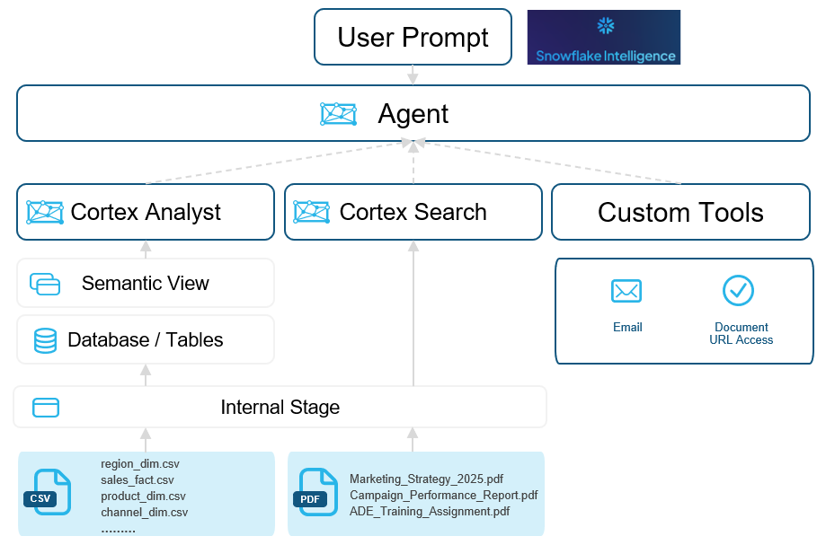
Figure 1: Architecture for building an agent

Marketers interact with one agent, in natural language, and the agent decides when to query data vs documents (or both).

4. Building the agent

4.1 Environment Setup
Goal: Create a dedicated environment (role + warehouse + database/schema) for the marketing intelligence demo.
You can think of this as creating a “sandbox” specifically for marketing analytics and the agent.
SQL Code:
environment_setup.sql

4.2 Create roles and other basic objects

SQL Code: Part of the environment_setup.sql
Why this matters: the role determines what you’re allowed to create; the db/schema is where all demo objects live; the warehouse runs your compute.

4.3 Staging + data (upload CSVs, then load)
This section focuses on preparing your raw structured data for ingestion into Snowflake. We define the required file formats, create an internal stage to hold the source files, upload marketing CSVs, and finally bulk-load them into the marketing star-schema tables for downstream analytics and agent reasoning.

4.3.1 File format + internal stage

Define a consistent CSV file format and create an internal Snowflake stage where all structured datasets (dimensions and facts) will be uploaded. The file format enforces parsing rules, while the stage acts as temporary storage for the raw files before they are loaded into tables.
SQLCode: create_file_format.sql

4.3.2 Create the minimal marketing star schema

Build a lightweight but realistic marketing data model that includes key dimensions (campaigns, channels, accounts, contacts, products, regions) and fact tables (marketing_campaign_fact). This schema forms the structured backbone of the Marketing Intelligence Agent and feeds Cortex Analyst with clean, relational data.
SQL Code: marketing_star_schema.sql

4.3.3 Upload CSVs to your stage

Manually upload all marketing CSV files: dimension tables, fact tables, and CRM datasets into the internal Snowflake stage using Snowsight’s “Load Data” UI. This makes the files available for COPY INTO operations, ensuring Snowflake can ingest them efficiently.

4.3.4 Load the data

Goal: Bulk-load CSVs into the tables we just created.
Description:
Use Snowflake’s COPY INTO command to load all CSV files from the stage into their corresponding tables. This step finalizes the structured dataset, validates row counts, and ensures the marketing schema contains quality data for semantic modeling and agent analytics.
SQL Code: load_data_to_tables.sql

4.4 Marketing semantic view (for cortex analyst)

Goal: Create a semantic view that describes the marketing data in business terms so Cortex Analyst can translate natural language into SQL.
From a marketer’s perspective, this is where you define:
- “What is a lead, opportunity, revenue?”
- “How do campaigns link to revenue?”
SQL Code: marketing_semantic_view.sql

4.5 Create Cortex Search Services (for PDFs)

4.5.1 Upload PDFs to internal stage

Goal: Make your marketing PDFs accessible for indexing.
In Snowsight:
- Go to Data -> SF_AI_DEMO -> DEMO_SCHEMA -> Stages -> INTERNAL_DATA_STAGE.
- Click Upload Files.
- Upload marketing PDFs with paths like:
- unstructured_docs/marketing/Marketing_Strategy_2025.pdf
- unstructured_docs/marketing/Campaign_Performance_Report.pdf
- unstructured_docs/marketing/2025_Marketing_Strategy.pdf

4.5.2 Parse the PDFs, build search service

Goal: Convert PDF content into text and index it, so marketers can search strategy and guidelines in natural language.
SQL Code: cortex_search_service.sql

4.6 Agent custom tool capability: Enable Email

Now we enable two powerful capabilities:
- Email tool: so, the agent can email a campaign summary or performance recap to a marketer.
- Dynamic document URL tool: so, the agent can turn a document ID into a shareable hyperlink.

4.6.1 Create notification integration

This step enables Snowflake to send emails directly from the agent. We create a Snowflake EMAIL notification integration, authorize it, and allow the agent to use it so marketing users can receive alerts, summaries, or follow-ups directly from within Snowflake.
SQL Code: email_notification_integration.sql

4.6.2 Create Utility Functions: helper procedure

Here we build small utility procedures like a function to send emails or generate pre-signed URLs for documents. These helper tools extend the agent’s capabilities, allowing it to share files, trigger notifications, and provide actionable outputs beyond data insights.
SQL Code: utility_procedures.sql

4.7 Building the agent

Goal: Create a single agent tuned for marketing questions that can:
- Query the marketing semantic view (Cortex Analyst).
- Search marketing PDFs (Cortex Search).
- Send emails and generate presigned document links.
SQL Code: cortex_agent.sql

5. Validation & Troubleshooting

No rows in tables?
- Double-check the CSV paths under @INTERNAL_DATA_STAGE/demo_data/.
- Re-run the COPY INTO commands.
Search service returns no results?
- Confirm PDFs are under unstructured_docs/marketing/.
- Re-run the parsed_content creation and Search_marketing_docs creation.
Email not sending.
- Ensure the ai_email_int integration is enabled and configured for your domain.
- Test directly:
CALL SEND_MAIL('<your_email@company.com>', 'Test from Marketing Copilot', '<h3>Hello from Snowflake!</h3>');
Agent not visible?
- Make sure you’re in the same account/region and have usage on snowflake_intelligence DB and snowflake_intelligence.agents schema.

6. Sample Queries to Try

This section aligns to how a marketing user will interact with the agent across four capabilities:
- Descriptive/Historical Queries – “What happened?”
- Diagnostic/Reasoning Queries – “Why did it happen and how should I respond?”
- Cortex Search (Unstructured Docs) – “What do our strategy decks and PDFs say about this topic?”
- Custom Tools (Email) – “Help me act on this insight directly from the agent.”

6.1 Descriptive/Historical Queries

Purpose
Provide clear, factual answers about past performance in a way that’s easy for marketers to understand and use.
Data source: Cortex Analyst on top of the MARKETING_SEMANTIC_VIEW (campaigns, channels, opportunities, accounts, etc.).
Example question a marketing persona might ask
- “For 2025, show me monthly total spend, impressions, leads, and total revenue by channel.”
What the agent does
- Uses Cortex Analyst to:
  - Group data by month and channel.
  - Aggregate spend, impressions, leads, and revenue for each combination.
- Returns:
  - A table (and optionally a chart) showing monthly performance by channel.
  - A short summary such as:
    - Which channels have highest spend vs highest revenue.
    - Which channels appear more efficient at converting spend into leads or revenue.

6.2 Diagnostic/Reasoning Queries

Purpose
Help marketers understand why performance looks the way it does and provide guidance on where to optimize.
Data source: Mostly Cortex Analyst, using metrics like spend, revenue, ROAS, conversion rates, and trends over time.
Example questions
- Channel performance vs ROAS
  - “Considering different metrics for ROAS (return on ad spend), which channels are performing better against the others in what scenarios?”
What the agent does:
  - Calculates ROAS and related metrics (e.g., revenue/spend, opportunities/spend) per channel.
  - Highlights:
    - Channels that perform better for top-of-funnel (impressions & leads).
    - Channels that perform better for pipeline & revenue.
- Seasonality and trends
  - “Based on all the data across all the channels, do you see certain seasonality and trend which typically gives a low ROI for certain time of the year, or days of the month? I am looking for this information so I can plan my spend better.”
What the agent does:
  - Analyzes performance across months and days.
  - Identifies:
    - Time periods where ROI or ROAS dip.
    - Time periods where campaigns typically overperform.
  - Explain patterns (e.g., weaker weekdays, specific off-season months, post-peak fatigue).
- Root cause of underperformance
  - “What could be the possible reason behind certain days of the month, or months of the year underperforming compared to the rest?”
What the agent does:
  - Compares underperforming periods with “normal” periods.
  - Looks at:
    - Changes in channel mix, campaign objectives, lead sources, or regions.
    - Shifts in close rates or pipeline quality.
  - Provides hypotheses like:
    - Over-reliance on lower-performing channels in those periods.
    - Lower-quality lead sources.
    - Misalignment between campaign objective and audience.

6.3 Cortex Search Service

Purpose
Augment numeric insights with context from marketing documents such as strategy decks, campaign reports, and playbooks.
Data Source: Cortex Search Service built on top of parsed marketing PDFs stored in @INTERNAL_DATA_STAGE.
Example question
- “Can you describe the Q4 2024 campaign performance from PDFs and give me the link to the corresponding PDFs?”
What the agent does
- Uses Cortex Search (not Cortex Analyst) to:
  - Search across all marketing PDFs for “Q4 2024 campaign performance”.
  - Extract:
    - Summary text describing Q4 results.
    - Key commentary from strategy decks or post-campaign reviews.
  - Return:
    - A short narrative of how Q4 2024 performed (e.g., key wins, misses, strategic themes).
    - Hyperlinks to the exact PDFs that contain those insights so the marketer can deep-dive.

6.4 Custom Tools

Purpose
Allow marketers to act on insights immediately without leaving the agent — in this case, by sending email summaries.
Custom tool wired to the SEND_MAIL stored procedure, backed by an EMAIL notification integration.
Example question
- “Can you send me an email with monthly total spend for 2025?”
What the agent does
- Uses Cortex Analyst to:
  - Compute monthly spend for 2025.
- Uses the Send_Emails custom tool to:
  - Compose an HTML email with a simple table or summary.
  - Send it to the user’s email address via the ai_email_int notification integration.
This closes the loop from insight - action, so the marketer not only sees the answer but also gets a shareable, persistent artifact they can forward or save.

7. Governance and monitoring

A marketing intelligence agent requires strict governance to ensure accuracy, trust, actionability, and enterprise safety. Snowflake provides end-to-end observability across SQL generation, LLM reasoning, tool orchestration, semantic integrity, performance, and cost so teams can validate outputs, troubleshoot issues, enforce controls, and maintain consistent marketing insights at scale. Governance spans four pillars: data quality, semantic governance, agent execution transparency, and operational controls.
Governance Layers:

7.1 Data Quality & Semantic Governance

- Ensure semantic view definitions (metrics, facts, synonyms) match business logic.
- Enforce versioning of semantic views.
- Use Verified Queries for high-risk or financially sensitive KPIs.
- Apply data profiling: row counts, NULL checks, anomaly detection.
Why it matters: Ensures that marketing KPIs like spend, impressions, leads, opportunity counts, and ROAS are always correct and reproducible.

7.2 Tool Governance (Analyst, Search, Email, URL Generator)

- Restrict tools with RBAC to ensure only required personas can send emails or access search results.
- Add rate limits or warehouse sizing controls to prevent misuse.
- Audit tool invocations using Snowflake’s built-in logs.
Why it matters: Prevents unauthorized communication, data leakage, or cost overruns.

7.3 Cortex Agent Observation Plane:

The Analyst Execution view shows exactly how a marketer’s natural-language question is translated into SQL. You can review the original query, the generated SQL, the reasoning behind selected dimensions and joins, the final response, and whether a verified (governed) query was used. It also displays execution status and performance timing. This provides full transparency into how the agent computes key marketing KPIs like spend, leads, revenue, and ROAS ensuring correctness, trust, and alignment with business logic.
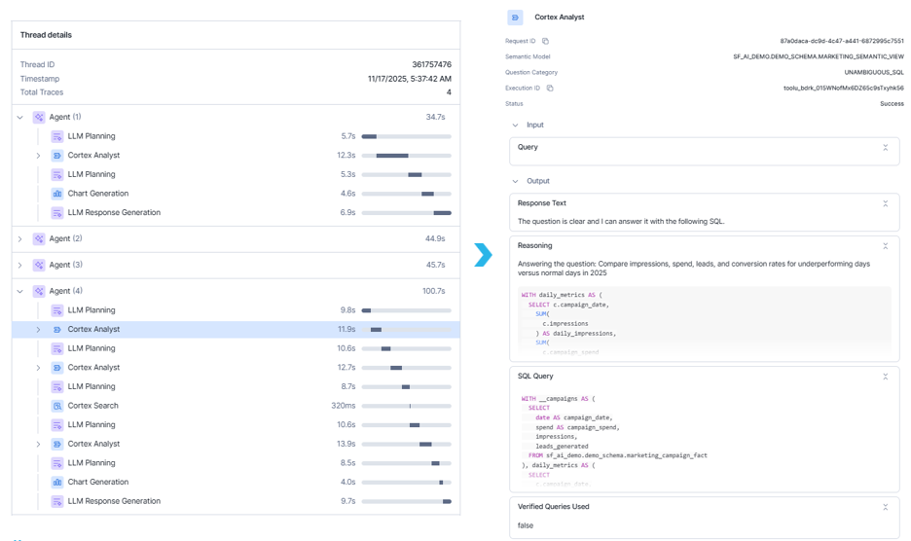
Figure 2: Deep Dive into Cortex Analyst Execution View

The LLM Planning view reveals how the agent decides which tool to use and how it plans to answer a question. It shows the user query, conversation context, available tools, reasoning for tool selection, and the full execution plan. You can also monitor token usage and cost estimates, plus confirm that the agent followed domain guardrails and rules. This view helps ensure safe orchestration, cost efficiency, and reliable behavior across Cortex Analyst, Cortex Search, and custom tools.
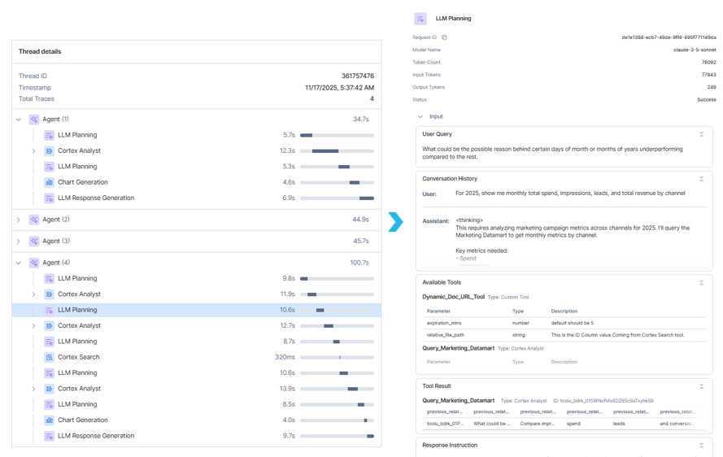
Figure 3: Deep Dive into LLM Planning View

8. Summary

In this guide, you built a Marketing Intelligence Copilot inside Snowflake, tailored specifically for a marketing persona:
- A marketing data mart with campaign, channel, region, and CRM-linked revenue tables.
- A marketing semantic view for Cortex Analyst to translate natural language questions into SQL.
- A Cortex Search Service over marketing PDFs for strategy, guidelines, and qualitative context.
- A Snowflake Intelligence Agent that:
  - Answers Descriptive/Historical Questions about performance.
  - Supports Diagnostic/Reasoning Queries to explain the “why” and suggest optimizations.
  - Handles Joint Queries, combining metrics and strategy documents in a single response.
  - Optionally sends emails and shareable links to documents.

9. Future Enhancements

As powerful as the current Retail Marketing Intelligence Agent is, there are several areas where the solution can be expanded to support deeper analytics, richer automation, and enterprise-scale activation. Below are the key enhancements that can be added in the next phases:
  - Support specific functions: Add Forecasting & Predictive Modeling
Integrate Snowflake ML or Snowpark ML models to forecast campaign performance, ROAS, lead conversion, or revenue. This would enable the agent to answer forward-looking questions such as “What will my expected ROI be if I increase paid search spend by 20% next quarter?”
  - Other Communication tools: Slack/Teams
Send messages, dashboards, summaries, or alerts directly to a Slack channel or MS Teams group
  - Incorporate external data
Scrape data from public websites, analyze its impact on internal data, and then synthesize the results
  - Enable automation
Automate remediation by having tools automatically detect and fix issues without human intervention.

